
Branding Audit Report
Current versus optimized LinkedIn profile and positioning
SAMPLE DATA. This report was generated from a fictional person and illustrative figures so you can see the finished format. It is not a real result.

Document control
Project | LinkedIn Influence Lab (Phase 1, 6 weeks)
Project code | LIL-2025-P1
Document | Branding Audit Report
Prepared for | Meera Kapoor (Sample), Founder
Learning path | Thought Leader / Entrepreneur
Version / date | 1.1 · 13 November 2026
Classification | Confidential: client use

1. Summary
63/100  Profile health score | Solid base  Assessment | 4  Checklist gaps | 5  Content pillars

The profile scores 63 out of 100 against a 12-point checklist drawn from the project brief. 4 items need attention; the five highest-value fixes are listed in section 3.

2. Profile checklist
Checklist item | Points | Score | Status | Recommended fix
Professional profile photo | 8 | 8 | OK
Banner that states your value | 6 | 6 | OK
Keyword-rich headline (60-220 chars) | 14 | 4 | Gap | Use: role | who you help / what you do | 2-3 skills. Avoid a bare job title.
About section with proof and a call to action | 14 | 7 | Gap | Write 600-1,500 characters: hook, proof, what you post about, how to reach you.
Custom profile URL | 4 | 4 | OK
Featured section populated | 8 | 8 | OK
15+ skills, top 3 pinned | 6 | 6 | OK
3+ recommendations | 8 | 8 | OK
Experience bullets include numbers | 12 | 0 | Gap | Rewrite each role with one measurable result.
Creator mode / Follow button on | 6 | 6 | OK
Posting at least 8 times a month | 8 | 0 | Gap | Start with the 6-week calendar from this project.
500+ connections | 6 | 6 | OK

3. Priority actions
- Experience bullets include numbers: Rewrite each role with one measurable result. (up to +12 points)
- Keyword-rich headline (60-220 chars): Use: role | who you help / what you do | 2-3 skills. Avoid a bare job title. (up to +10 points)
- Posting at least 8 times a month: Start with the 6-week calendar from this project. (up to +8 points)
- About section with proof and a call to action: Write 600-1,500 characters: hook, proof, what you post about, how to reach you. (up to +7 points)

4. Headline: current and optimized
 | Headline
Current | Founder at Clearpath Analytics
Option 1 | AI adoption workshops for mid-size companies | Helping founders and heads of data at mid-size companies win with Data Strategy | Writing on data and AI consulting
Option 2 | Founder at Clearpath Analytics | AI adoption workshops for mid-size companies for founders and heads of data at mid-size companies | Weekly ideas on data and AI consulting
Option 3 | Founder at Clearpath Analytics | Making Data Strategy simple for founders and heads of data at mid-size companies

5. About section: optimized draft
Before you use it Source: Template engine. Replace every [bracketed placeholder] with a real, verifiable example before publishing.

I help founders and heads of data at mid-size companies get more from Data Strategy through AI adoption workshops for mid-size companies.
What I bring:
• A workshop I ran helped a 60-person company launch its first AI-assisted reporting process in three weeks.
• I once built a beautiful data roadmap that nobody owned, and it stalled in the first month.
• A plan without a named owner is just a document.
What I write about: career insights, thought leadership, personal journey, industry trends, actionable tips.
Skills I use most: Data Strategy, AI Adoption, Analytics Leadership, Storytelling with Data.
If you want to talk about data and AI consulting, send me a message or follow along.

6. Content pillars
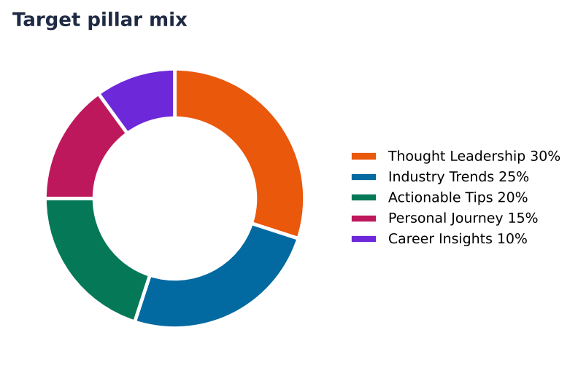
Figure 1. Target pillar mix for the six-week plan
Pillar | Share | Posts in 6 weeks | What it covers | Example topic
Thought Leadership | 30% | 5 | Opinions, frameworks and bets that make people think. | Unpopular opinion: most data and AI consulting advice about Data Strategy is outdated
Industry Trends | 25% | 4 | What is changing in your field, explained in plain English. | 3 shifts in data and AI consulting that founders and heads of data at mid-size companies should watch this quarter
Actionable Tips | 20% | 4 | Checklists, templates and habits people can use today. | 5 minutes a day on Data Strategy: the routine that actually stuck
Personal Journey | 15% | 3 | Honest stories: wins, mistakes and what you are learning. | My biggest mistake as a Founder (and the lesson I still use)
Career Insights | 10% | 2 | Hard-won lessons about growth, promotions and decisions. | The best career advice I ignored for years (and what finally changed my mind)

7. Role-model benchmark
Role model | Profile | What to learn
Sample Founder A | https://www.linkedin.com/in/sample-founder-a | Contrarian takes backed by one example
Sample Author B | https://www.linkedin.com/in/sample-author-b | Weekly series with a recognisable format
Sample Speaker C | https://www.linkedin.com/in/sample-speaker-c | Carousels that get saved and shared

8. The three user paths compared
Path | Goal | Rhythm | Pillar mix | KPIs
Working Professional | Visibility and credibility inside my niche. | Tue, Wed, Thu | Career Insights 29%, Thought Leadership 24%, Industry Trends 24%, Actionable Tips 24% | Impressions, Comments, Profile visits
Job Seeker | Recruiter attention, interviews and inbound opportunities. | Mon, Wed, Fri | Actionable Tips 33%, Personal Journey 28%, Career Insights 22%, Industry Trends 17% | Profile visits, Recruiter messages, Connection requests
Thought Leader / Entrepreneur | Authority, followers, shares and inbound leads. | Tue, Thu, Sat | Thought Leadership 33%, Industry Trends 28%, Actionable Tips 22%, Personal Journey 17% | Followers gained, Shares, Inbound leads

